Big Data Mart Sale Prediction

A Comparative Study of Big Mart Sales



Submitted By:Ravisankar PK
Student at Data Trained
Batch:-1841
ravis453@gmail.com

Abstract:- Nowadays shopping malls and Big Marts keep the track of their sales data of each and every individual item for predicting future demand of the customer and update the inventory management as well.These data stores basically contain a large number of customer data and individual item attributes in a data warehouse. The resultant data can be used for predicting future sales volume with the help of diﬀerent machine learning techniques. In this report, we propose a predictive model using Gradient Boosting Regressor model for predicting the sales of a company like Big Mart and found that the model produces better performance as compared to existing models.

- Introduction

Day by day competition among diﬀerent shopping malls as well as big marts is getting more serious and aggressive mainly due to the rapid growth of the global malls and on-line shopping. Every mall or mart is trying to provide personalized and short-time oﬀers for attracting more customers depending upon the day, such that the volume of sales for each item can be predicted for inventory management of the organization, logistics and transport service, etc. Present machine learning algorithm are very sophisticated and provide techniques to predict or forecast the future demand of sales for an organization, which also helps in overcoming the cheap availability of computing and storage systems.In this paper, we are addressing the problem of big mart sales prediction or forecasting of an item on customer’s future demand in diﬀerent big mart stores across various locations and products based on the previous record. Diﬀerent machine learning algorithms like linear regression analysis, random forest, etc are used for prediction or forecasting of sales volume.
Machine learning techniques can not only handle non-linear data but also huge data-set eﬃciently. To measure the performance of the models, Root Mean Square Error (RMSE) [15] and Mean Absolute Error (MAE) [4] are used as an evaluation metric as mentioned in the Equation 1 and 2 respectively. Here Both metrics are used as the parameter foraccuracy measure of a continuous variable.

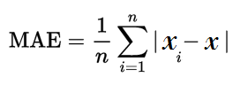

where n: total number of error and xpredict −xactual:Absolute error.

- Problem Statement

The data scientists at BigMart have collected 2013 sales data for 1559 products across 10 stores in different cities. Also, certain attributes of each product and store have been defined. The aim is to build a predictive model and find out the sales of each product at a particular store.

Using this model, BigMart will try to understand the properties of products and stores which play a key role in increasing the sales of their products.

3.Proposed Work

System for building a model to predict sales each item from the dataset of Big Mart sales.This undergoes several sequence of steps. in this work we propose a model using Gradient Boosting Regressor technique. Every step plays a vital role for building the proposed model. In our model we have used 2013 Big mart dataset .After conducting Exploratory Data Analysis , Visualizations, Removed Outliers, Removed Skewess , used Encoding Techniques, and after Standardization we used variour Regressor models using AdaBoost Regressor, Random Forest Regressor, Gradient Boosting Regressor,KNN Regressor. For Evaluating and find the accuracy of the model we used, R2 Score , MAE,MSE and RMSE . The details of the proposed method is explained in the following section.

Visualization
EDA
Data Cleaning
Importing Libraries & DATSET
Testing
Modeling
Future Engineering

Result/ Prediction

Turning

3.1 Importing Libraries and Data Set

In our work we have used 2013 Sales data of Big Mart as the dataset. Where the dataset consists of 12 features like 'Item_Identifier', 'Item_Weight', 'Item_Fat_Content', 'Item_Visibility','Item_Type', 'Item_MRP', 'Outlet_Identifier','Outlet_Establishment_Year', 'Outlet_Size', 'Outlet_Location_Type', 'Outlet_Type', 'Item_Outlet_Sales'. Out of these our Label is the Item Outlet Sales attribute and remaining attributes are features or Predictive variables.The data-set consists of 8523 products across diﬀerent cities and locations.

3.2.A EDA

In this phase useful information about the data has been extracted from the dataset. We have a data set contains 8523 records or rows, and 12 features. Out of these features we checked the data types of each and we noticed around 7 object type and 5 numerical type data. While trying to identify the information from hypotheses vs available data. Which shows that the attributes Outlet_size and Item_weight face the problem of missing values. Also the minimum value of Item Visibility is zero which is not actually practically possible. Establishment year of Outlet varies from 1985 to 2009. These values may not be appropriate in this form. So, we need to convert them into how old a particular outlet is. There are 1559 unique products, as well as 10 unique outlets, present in the dataset. The attribute Item type contains 16 unique values. Where as two types of Item Fat Content are there but some of them are misspelled as ‘regular’ instead of ’Regular’ and ‘low fat’, ‘LF’ instead of ‘Low Fat.’ So we corrected these issues ‘.replace()’ method.

3.2.B Data Cleaning

It was observed from the previous section that the attributes Outlet_Size and Item_Weight has missing values. In our work in case of Outlet_Size missing value we replace it by the mode of that attribute and for the Item_Weight missing values we replace by mean of that particular attribute. The missing attributes are numerical where the replacement by mean and mode diminishes the correlation among imputed attributes.
As we noticed some same content spelt in different form, we replaced the same using ‘.replace()’ method.

3.3 Visualization

For using this section firstly we have to import seaborn and matapolt libraries.We observed all categorical feature using count plot to find the number of each items.Categorical columns are Item_Fat_Content, Item_Type, Outlet_Size, Outlet_Location_Type,Outlet_Establishment_Year, Some are shown below.

+ 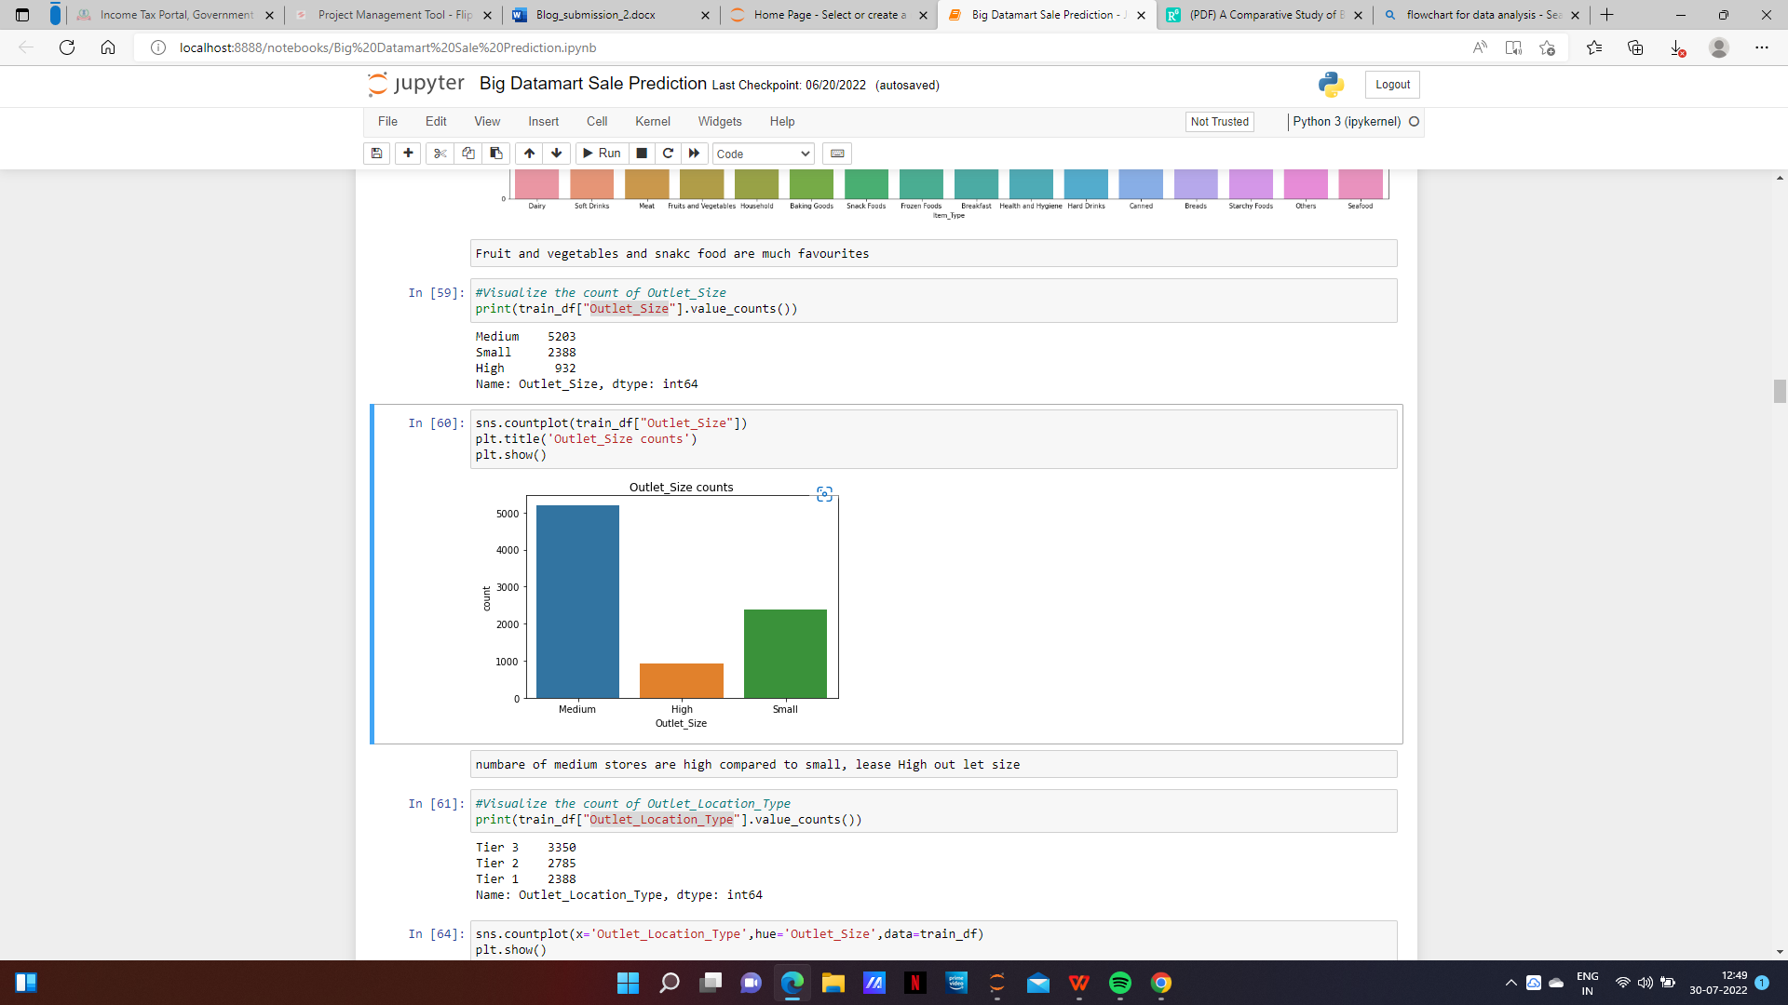

From this we can notice that there three type of Outlet_Size available, and we can easily notice that medium have maximum number of counts

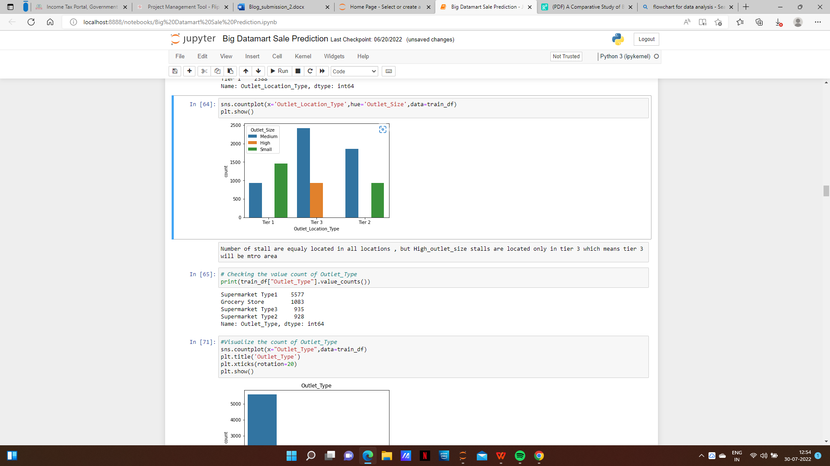

This we observed Outlet_Location_Type, also we added another feature to this count plot hue as Outlet_Size, from this we noticed the there are three Outlet_Location_Type T=and namely Tier-1,Tier-2,Tier-3, also we noticed high outlet size Bigmarts are location only in Tier-3, also small Bigmart are location in Ter-1 and Tier-2, Medium sizes out let located all over the locations.

Then we used pair plot to find the relation between numerical data, here we noticed some linear relation between some features. Some features does not have much relations

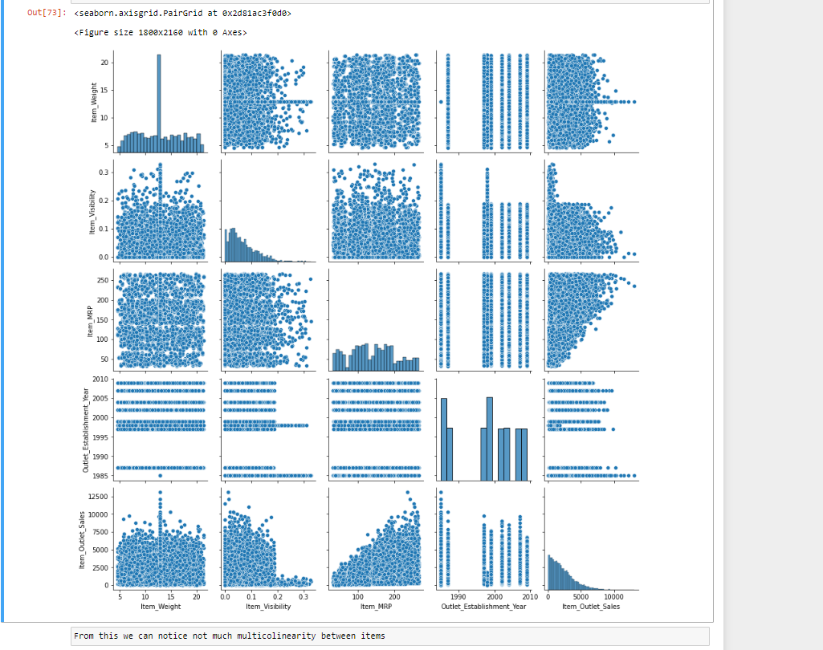

After observing this by variant analysis of features we arrived,
* Item price and Item MRP have high linear relation as Item price increases sale also increased.
* Item_Visibility and Outlet_sale were negatively related.

After this we used heat map to obtain and visualize correlation values of each variable with each other and with Label.

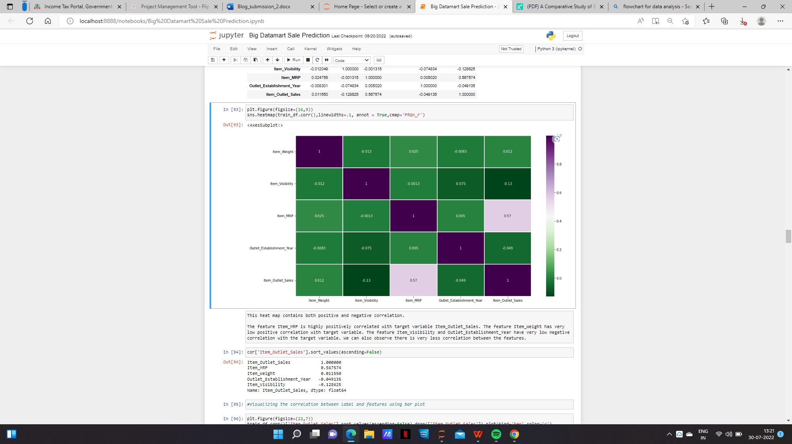
Then we bifurcated correlation between features and Label and plotted the same using BAR plot.

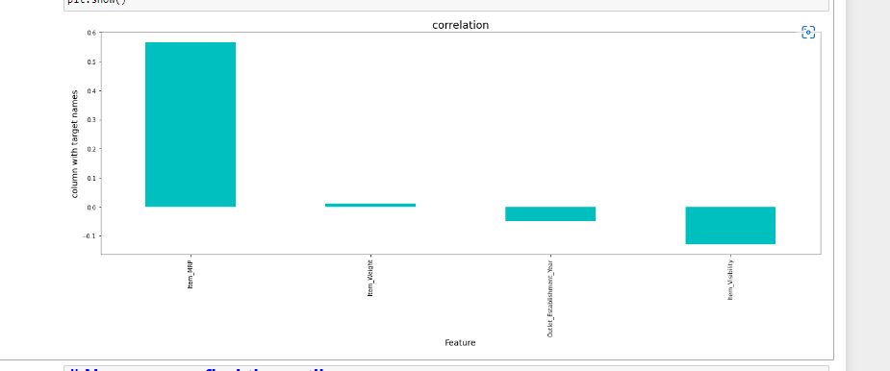

3.4 Feature Engineering

Some nuances were observed in the data-set during data exploration phase. So in this phase we will be resolving all nuances like outliers, skewness, from the dataset and make them ready for building the appropriate model. For obtaining the features with outliers present we used box plot, example shown below,

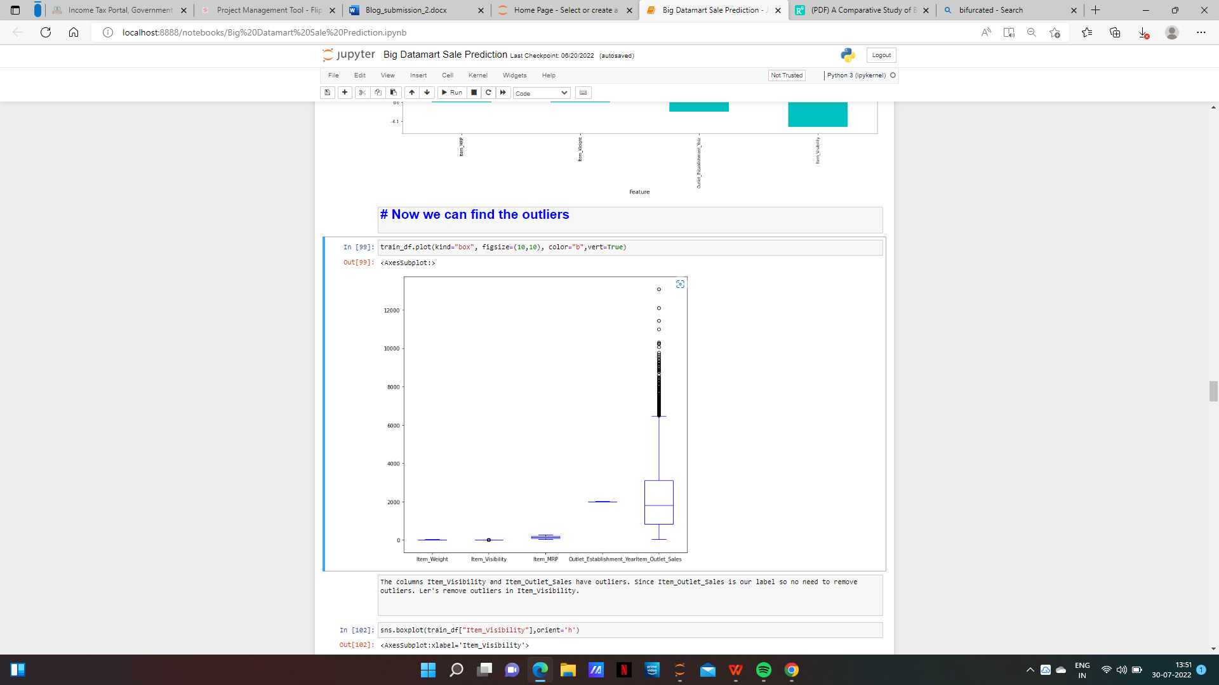

We noticed outliers in Item_Outlet_Sales, and Item_Visibility, but as Item_outlet_sale is our Label we need to remove outlier only from Item_visibility.
We checked removing outliers using Zscore method and IQR method, and used Zscore method for removal of same.

The we checked skewness using skew()function and also using by displot

new_df.skew()
Item_Weight 0.089907
Item_Visibility 0.795956
Item_MRP 0.128945
Outlet_Establishment_Year -0.409186
Item_Outlet_Sales 1.173070

Here also we noticed that Item_Visibility and Item_Outlet_Sales have skewness, so we removed the same using PowerTransform method.

sns.distplot(new_df['Item_Visibility'])

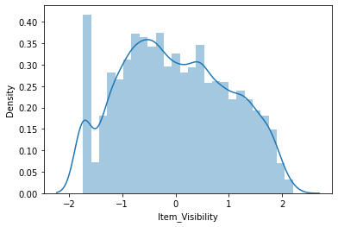

After completing this we again moved to process categorical features, we encoded all categorical features using LabelEcoder method, which we imported from sklearn.preprocessing import LabelEncoder

After that we noticed that all values in our data is in different forms so we have some convert the same in to some standard from by using any scalar function, so here we are using MinMaxScaler.

from sklearn.preprocessing import MinMaxScaler
mms=MinMaxScaler()
x = pd.DataFrame(mms.fit_transform(x), columns=x.columns)

By doing same we standardized our data , After that we will moves towards modeling, All the executed steps were equally important , Also we do many more preprocessing proceedures like, best feature selection, VIF techniques for removing multi corelated features, PCA etc,.

3.5 Modeling

After completing the previous phases, the dataset is now ready to build proposed model. Once the model is build it is used as predictive model to forecast sales of Big Mart. Before training the model we will find out best Random state.
In Our work we trained our data using five models, mentioned below

- Linear Regression
- Random Forest Regressor
- AdaBoost Regressor
- GradientBoosting Regressor
- KNN Regressor

After for each model we will find out the following,
R2_Score:- metrics.r2_score(y_test,predABR))
Mean Absolute Error:- mean_absolute_error(y_test, predABR))
'Mean Squared error:- mean_squared_error(y_test, predABR)
Root Mean Squared Error:- np.sqrt(metrics.mean_squared_error(y_test, predABR)

Let us check how all Algorithms works.

3.5.1 Linear Regression
Linear Regression is a machine learning algorithm based on supervised learning. It performs a regression task. Regression models a target prediction value based on independent variables. It is mostly used for finding out the relationship between variables and forecasting. Linear regression performs the task to predict a dependent variable value (y) based on a given independent variable (x). So, this regression technique finds out a linear relationship between x (input) and y(output). Hence, the name is Linear Regression.

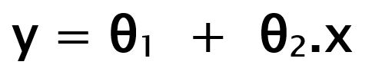

While training the model we are given :
x: input training data (univariate – one input variable(parameter))
y: labels to data (supervised learning)
θ1: intercept
θ2: coefficient of x

3.5.2 Random Forest Regressor

Every decision tree has high variance, but when we combine all of them together in parallel then the resultant variance is low as each decision tree gets perfectly trained on that particular sample data, and hence the output doesn’t depend on one decision tree but on multiple decision trees.

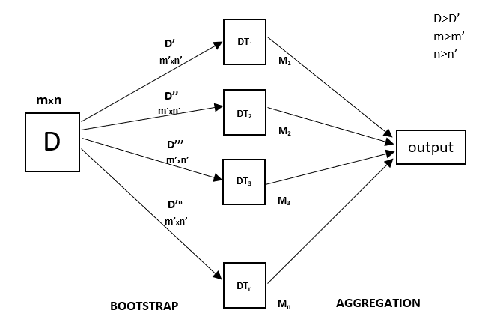

Random Forest is an ensemble technique capable of performing both regression and classification tasks with the use of multiple decision trees and a technique called Bootstrap and Aggregation, commonly known as Bagging.

3.5.3 AdaBoost Regressor

AdaBoost models belong to a class of ensemble machine learning models. From the literal meaning of the word ‘ensemble’, we can easily have much better intuition of how this model works. Ensemble models take the onus of combining different models and later produce an advanced/more accurate meta model. This meta model has comparatively high accuracy in terms of prediction as compared to their corresponding counterparts. We have read about the working of these ensemble models in the article Ensemble Classifier | Data Mining.

AdaBoost algorithm falls under ensemble boosting techniques, as discussed it combines multiple models to produce more accurate results and this is done in two phases:

Multiple weak learners are allowed to learn on training data
Combining these models to generate a meta-model, this meta-model aims to resolve the errors as performed by the individual weak learners

3.5.4 GradientBoosting Regressor

Gradient Boosting is a popular boosting algorithm. In gradient boosting, each predictor corrects its predecessor’s error. In contrast to Adaboost, the weights of the training instances are not tweaked, instead, each predictor is trained using the residual errors of predecessor as labels.

There is a technique called the Gradient Boosted Trees whose base learner is CART (Classification and Regression Trees).

The below diagram explains how gradient boosted trees are trained for regression problems.

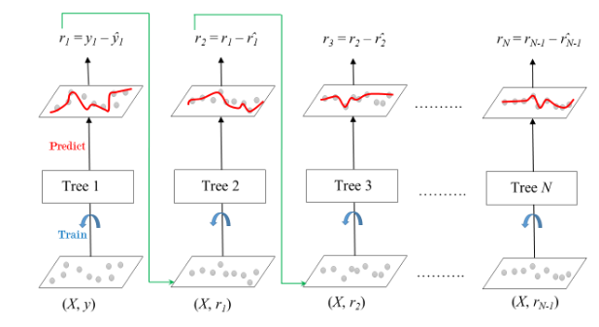

The ensemble consists of N trees. Tree1 is trained using the feature matrix X and the labels y. The predictions labelled y1(hat) are used to determine the training set residual errors r1. Tree2 is then trained using the feature matrix X and the residual errors r1 of Tree1 as labels. The predicted results r1(hat) are then used to determine the residual r2. The process is repeated until all the N trees forming the ensemble are trained.
There is an important parameter used in this technique known as Shrinkage.

Shrinkage refers to the fact that the prediction of each tree in the ensemble is shrunk after it is multiplied by the learning rate (eta) which ranges between 0 to 1. There is a trade-off between eta and number of estimators, decreasing learning rate needs to be compensated with increasing estimators in order to reach certain model performance. Since all trees are trained now, predictions can be made.
Each tree predicts a label and final prediction is given by the formula,

y(pred) = y1 + (eta * r1) + (eta * r2) + ....... + (eta * rN)

3.5.5 k-nearest neighbor algorithm

It is the learning where the value or result that we want to predict is within the training data (labeled data) and the value which is in data that we want to study is known as Target or Dependent Variable or Response Variable.

All the other columns in the dataset are known as the Feature or Predictor Variable or Independent Variable.

Supervised Learning is classified into two categories:

Classification: Here our target variable consists of the categories.
Regression: Here our target variable is continuous and we usually try to find out the line of the curve.

After finding out evaluation scores of each models we will moves to next step. Testing

3.6 Testing

In our work we set cross-validation as 5 fold cross-validation to test accuracy of diﬀerent models. Where in the cross-validation stage the dataset is divided randomly into 5 subsets with roughly equal sizes. Out of the 5 subsets, 4 subsets are used as training data and the remaining subset forms the test data, also called leave-one-out cross validation. Every models is ﬁrst trained by using the training data and then used to predict accuracy by using test data and this continues until each subset is tested once.
After doing this we will find the mean of cross validation scores each model. After that we will select the best model by finding smallest difference between R2score and Cross Validation Score.

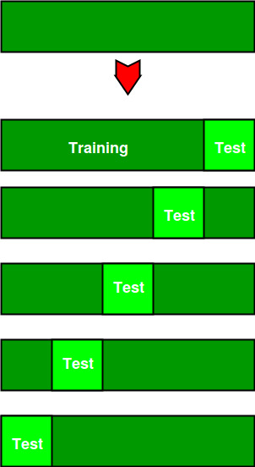

After finding this we conclude that GradientBoosting Regressor is the best algorithm having least difference between R2 score and Cross Validation Score

3.6 Turning

A Machine Learning model is defined as a mathematical model with a number of parameters that need to be learned from the data. By training a model with existing data, we are able to fit the model parameters.
However, there is another kind of parameters, known as Hyperparameters, that cannot be directly learned from the regular training process. They are usually fixed before the actual training process begins. These parameters express important properties of the model such as its complexity or how fast it should learn.

GridSearchCV

In GridSearchCV approach, machine learning model is evaluated for a range of hyperparameter values. This approach is called GridSearchCV, because it searches for best set of hyperparameters from a grid of hyperparameters values.

After finding best parameters for our model we will again Train our model with these identified best parameter.

After that we will again test the accuracy of our model and save the same for future findings of sale of the BIG Data Mart.

3.7 Prediction

After saving the model we will do all analysis on the separate test data provide and make predictions using the saved model.

4. Colusion

In present era of digitally connected world every shopping mall desires to know the customer demands before hand to avoid the shortfall of sale items in all seasons. Day to day the companies or the malls are predicting more accurately the demand of product sales or user demands. Extensive research in this area at enterprise level is happening for accurate sales prediction. As the proﬁt made by a company is directly proportional to the accurate predictions of sales, the Big marts are desiring more accurate prediction algorithm so that the company will not suﬀer any losses. In this research work, we have designed a predictive model by Gradient Boosting Regressor experimented it on the 2013 Big Mart dataset for predicting sales of the product from a particular outlet.

5.References

- https://www.geeksforgeeks.org/
- https://www.researchgate.net/
- What is Hyperparameter Tuning in Machine Learning? (mygreatlearning.com)
- https://towardsdatascience.com/big-data-analyses-with-machine-learning-and-pyspark-135119ef6b31?gi=abe8e9dd6315
- Linear Regression for Machine Learning (machinelearningmastery.com)

